Basic Chemistry Laboratory – I

I_3. Ion exchange column for removal of hardness of water

**Ion exchange column for removal of hardness of water**

**1. About the experiment**

Students will learn how the ion exchange column softens the hard water.

**2. Aim of the experiment**

Removal of hardness of water with measurement of hardness by the analytical titration.

**3. Theory of the Experiment:**

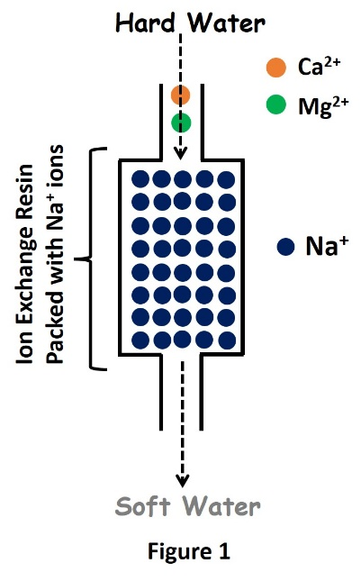The presence of calcium (Ca2+) and/or magnesium (Mg2+) in water results in water being considered “hard”. Calcium and magnesium ions in water react with soap to produce insoluble components and decrease the effectiveness of the soap for cleaning. Hard water can be softened using an ion exchange softening process. The ion exchange water softening process can remove nearly all calcium and magnesium from water. During ion exchange treatment, water is passed through a resin containing exchangeable ions. Stronger binding ions displace weaker binding ions and are removed from the water. There are two types of ion exchange – anion exchange and cation exchange. Anion exchange resins generally exchange chloride for anionic contaminants. Cationic ion exchange involves removing the hardness ions calcium and magnesium and replacing them with non-hardness ions, typically sodium supplied by dissolved sodium chloride salt, or brine. The ion exchange column contains a microporous exchange resin, usually sulfonated polystyrene beads that are supersaturated with sodium to cover the bead surfaces. As water passes through this resin bed, calcium and magnesium ions attach to the resin beads and the loosely held sodium is released from the resin into the water. The softening process is illustrated in Fig. 1. After softening a large quantity of hard water, the column becomes saturated with calcium and magnesium ions. When this occurs, the exchange resin must be regenerated, or recharged. To regenerate, the ion exchange resin is flushed with a brine or sodium hydroxide solution. The sodium ions in the solution are exchanged with the calcium and magnesium ions in the resin and excess calcium and magnesium is flushed out with wastewater.

The estimation of hardness is based on complexometric titration. Hardness of water is determined by titrating with a standard solution of ethylene diamine tetra acetic acid (EDTA) which is a complexing agent. Since EDTA is insoluble in water, the disodium salt of EDTA is taken for this experiment. EDTA can form four or six coordination bonds with a metal ion.

EDTA **(**Ethylenediamine tetra acetic acid) forms colourless stable complexes with Ca2+and Mg2+ ions present in water at pH = 9-10. To maintain the pH of the solution at 9-10, a buffer solution (NH4Cl + NH4OH) is used. Eriochrome Black-T (E.B.T) is used as an indicator. The sample of hard water must be treated with buffer solution and EBT indicator which forms an unstable, wine-red colored complex with Ca2+and Mg2+ present in water.

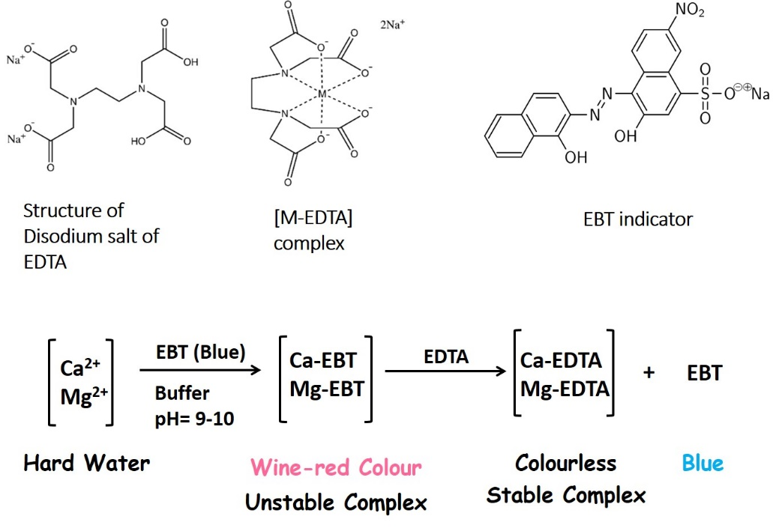

**4. Pre-test questions and answers**

1) What do you mean by hard water?

* The water contains Ca2+ and Mg2+ ions
* The water contains specifically Fe3+ with little Ca2+ and Mg2+ ions
* The water contains Cl-, Br- and PO43- ions.
* The water contains bacterial infections.

2) The resin used for ion exchange should contain

* Non-exchangeable ions
* Larger ions
* Permeable ions
* Exchangeable ions

3) The ion exchange column contains a microporous exchange resin usually made by

* Sulfonated graphitic carbon nitride
* Sulfonated polystyrene beads
* Carbonylated polyvinyl chloride
* Hydroxylated borophene

4) When soap fails in effective cleaning?

* When water contains alcohol
* When water contains bacteria
* When water is hard
* When the chloride content water is high

5) To remove the hardness of water, what type of resin should be used?

* Both cation exchange and anion exchange resins
* Only anion exchange resin
* Only cation exchange resin
* Silica resin

**5. Procedure**

**5.1. Materials & Reagents Required:**

1. Tap water (100 mL)
2. Conical flask (250 mL)
3. Weighing balance
4. Dropper
5. Glass column
6. Measuring cylinder (10 mL)
7. Burette (50 mL)
8. Cation exchange resin
9. EDTA (0.01 M)
10. Ammonia buffer (pH 10)
11. EBT indicator

**5.2. Procedure in laboratory (diagram)**

**Repeat Step-1 to Step-3 three times and make the following table.**

**Titration of hard water (normal tap water)**

|  |  |  |  |  |
| --- | --- | --- | --- | --- |
| Sl. No. | Volume of water (mL) | Initial reading (mL) | Final reading (in mL) | Volume of EDTA (mL) |
| 1 |  |  |  |  |
| 2 |  |  |  |  |
| 3 |  |  |  |  |

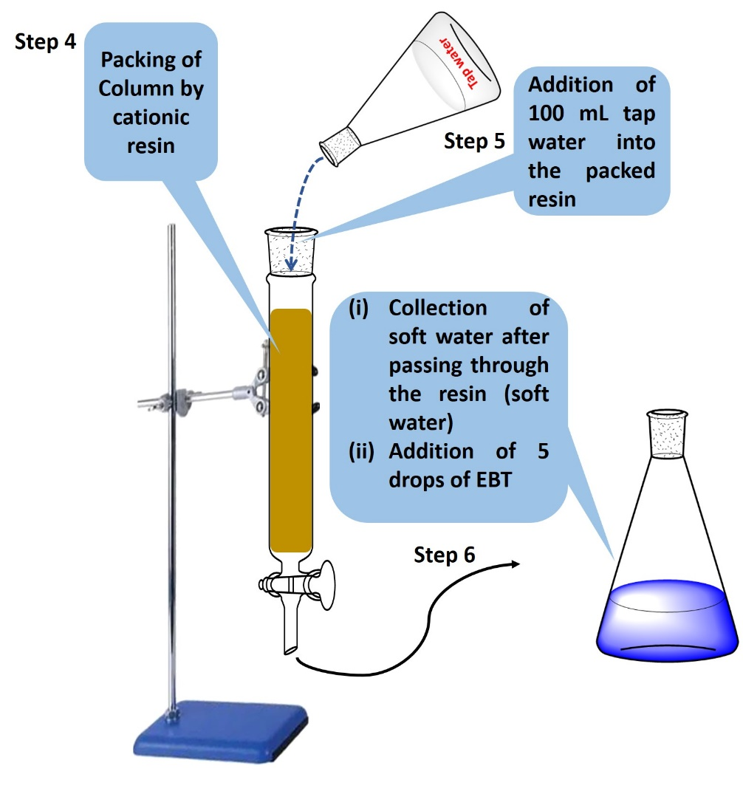

**Repeat Step-5 and Step-6 three times.**

**5.3. Procedure in laboratory**

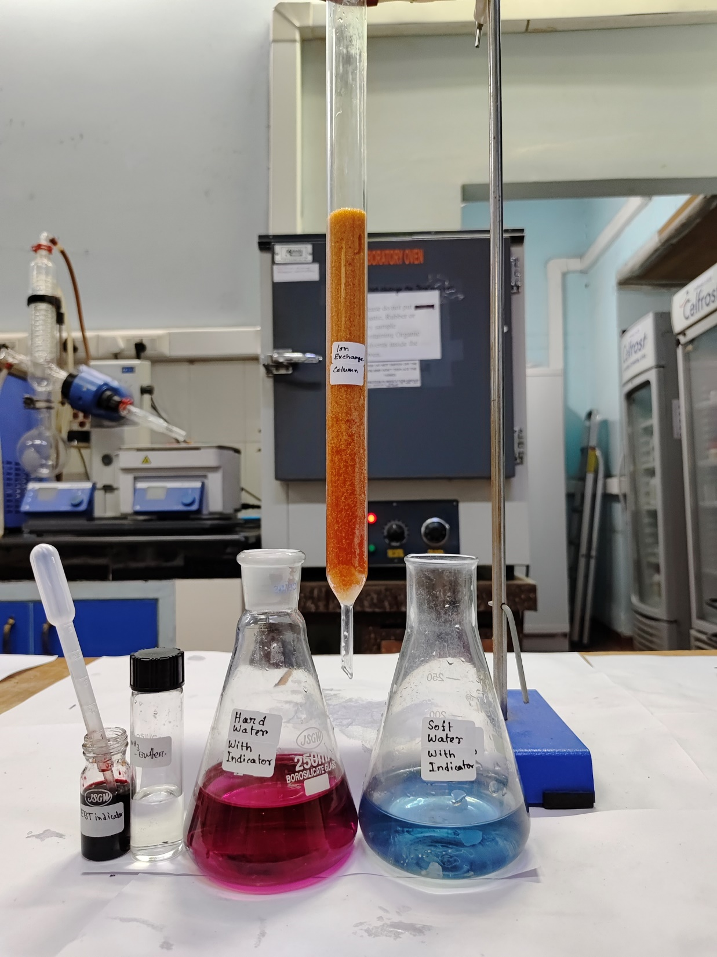

**See the Video!**

**5.4 Observation**

The color of soft water instantly changed into blue, while the hard tap water turned wine red when Eriochrome black T was added. The wine-red colored solution turned blue when titrated against the EDTA solution.

**5.5. Data and the analysis**

**5.5.1 Titration of hard water (normal tap water)**

|  |  |  |  |  |
| --- | --- | --- | --- | --- |
| Sl. No. | Volume of water (mL) | Initial reading (mL) | Final reading (in mL) | Volume of EDTA (mL) |
| 1 | 100 | 0 | 9.2 | 9.2 |
| 2 | 100 | 9.2 | 18.4 | 9.2 |
| 3 | 100 | 18.5 | 27.9 | 9.4 |

Therefore, the average volume of EDTA needed is 9.3 mL.

**5.5.2 Calculation**

Total hardness of water mg/L = $$\frac{ml of EDTA used \left(unboiled\right) × {10}^{3}}{mL of Sample}$$

$= \frac{9.3 × {10}^{3}}{100}$ $= 93 mg/L$ $= 93 ppm$

**5.5. Procedure in simulator of the experiment**

*To be added based on the simulation*

**6. Simulator**

*To be created*

**7. Analysis**

From the experiment, the hardness of tap water is found to be 93 ppm

**8. Post Test Questions and answers**

1) The cation exchange resin which was used to remove the hardness of water contains

* Na+ ions.
* Fe3+, Ca2+ and Mg2+ ions
* Ca2+ and Mg2+ ions
* Mg2+ ions only.

2) After softening of hard water, the cation exchange resin was contained by

* Na+ ions.
* Only Sulfonated polystyrene beads
* Fe3+ ions
* Ca2+ and Mg2+ ions

3) To measure the hardness of the water, which solution was used as a complexing agent?

* The Cu (II) Phenanthroline complex
* Barium salt of EDTA
* Disodium salt of EDTA
* 18-crown ether-6

4) What indicator was used during the titration for measuring the hardness of the water?

* Methyl orange
* Eriochrome Black-T
* Bromocresol green
* Phenolphthalein

5) At the end point of the titration, the color of the used indicator was turned brine red to blue due to

* Formation of metal-indicator complex
* The metal-indicator complex dissociates, and the indicator becomes free.
* For increasing the basicity of the solution
* No reasons mentioned above.

**9. References:**

**A**. Ryznar, John W.; Langelier, W. F. (April 1944). "A New Index for Determining Amount of Calcium Carbonate Scale Formed by a Water".

**B**. Langelier, W. F. (October 1936). "The Analytical Control of Anti-Corrosion Water Treatment". Journal of the American Water Works Association. 28 (10): 1500–1521.

**C.** "Map showing the rate of hardness in mg/L as Calcium carbonate in England and Wales" (PDF). DEFRA/ Drinking Water Inspectorate. 2009.